YOGASANAS IN STANDING POSITION

VRIKSHASANA
Tree pose
Introduction:
A healthy tree is always upright, remains stable, and grows upward. The body takes the same position in this asana, hence it is called Vrikshasana.
Taking the Asana Position:
Initial Position: Standing Position
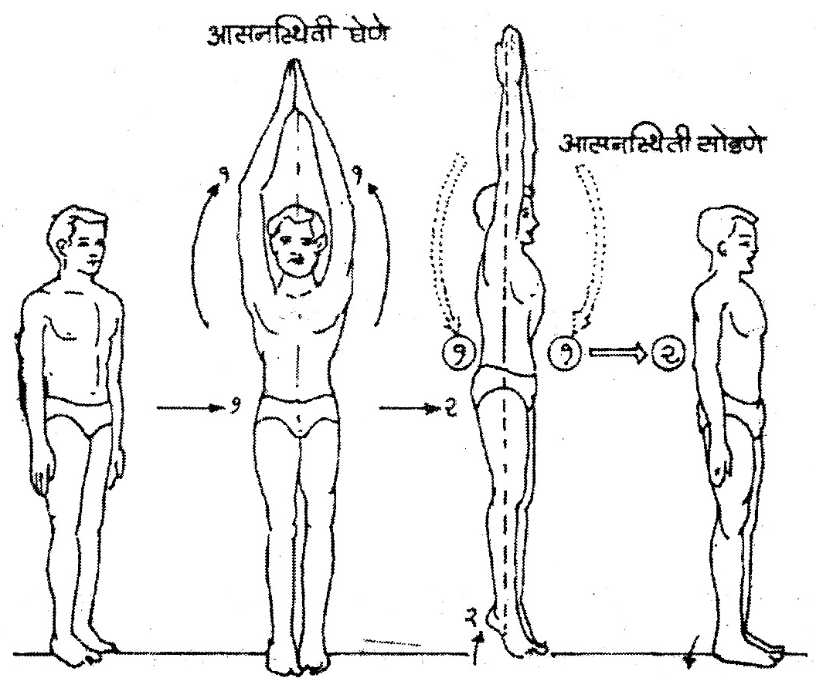
1) Exhale, and while inhaling, raise both arms up above the head, joining the palms in Namaskar.
2) Lift the heels and stand on the toes, stretching the whole body upward. Continue normal breathing.

The Asana Position:
Aside from the toes, the whole body from heels to fingers is stretched. Pull the hands upward as much as possible. The more the body is stretched, the easier it is to keep the balance. Keep the legs stable. Holding the asana position, continue normal breathing and fix the gaze straight ahead. Focus on one point to help maintain stability.
Releasing the Asana Position:
1) Inhale, and while exhaling, bring both the hands down to the sides.
2) Bring the heels to the floor and return to standing position.
Duration:
As this asana involves balancing, it is enough to maintain it for one minute. One should increase this duration to three minutes to receive certain benefits.
Internal Effects:
Different kinds of strains are caused in the muscles while doing the various asanas. However, these strains should subside when the asanas are released. Vrikshasana helps get rid of all such strains. In this asana, all the muscles are stretched in one direction and then relaxed. This asana should be done at the end of the Yoga practice.
In any movement of the body, when one muscle is contracted, another is expanded. However, in this asana all muscles are stretched at one time and in one direction. Consequently, the strain caused in these muscles operates at one time and in the same direction. As a result, the muscles get relaxed and the earlier strains caused by other asanas are removed.
Precaution:
There are no real precautions to this asana. However, while stretching the body upward, one should take care to maintain the balance. One should be careful if the ankles are weak; this asana puts a lot of strain on the ankle joints.

VIRASANA
Warrior pose
Introduction:
It is a bit unclear how VIrasana was named. However, Vira roughly means “brave”. The stance taken in this asana resembles the way a brave man, or warrior, takes position before attacking his enemy.
Taking the Asana Position:
Initial Position: Standing Position
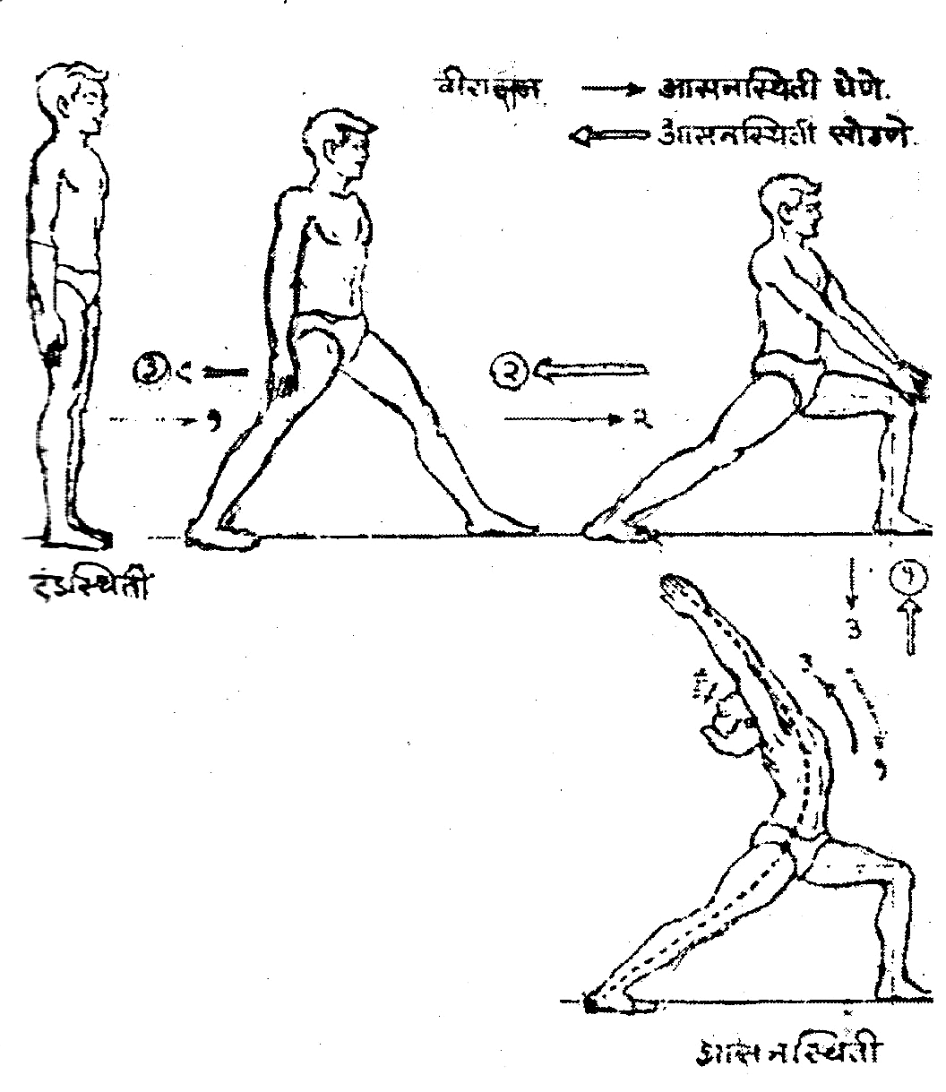

1) Step the left leg forward and place the left foot on the floor. The distance between the feet should be as wide as possible.
2) Bring both the hands together, join the palms in Namaskar, and place them on the knee of the left leg. Bend the left leg at the knee so that the thigh and the calf form a 90 degree angle. Keep the right leg straight.
3) Raise the arms and joined hands up, and take them back above the head. Keeping the arms straight, bend the head back and look up and back.
The Asana Position:
This asana is done with good results if the front leg is placed as wide as possible from the back leg. It is also necessary to keep the front leg bent at a 90 degree angle and keep the back leg straight. Keep the toes of the back foot pointing forward. The back leg, the back, the neck and both the hands form a very good arch in this position. For this the body weight should be placed on the back leg. Keep the tops of the arms next to the ears, and keep the neck bent backwards.
Releasing the Asana Position:
1) Start bringing the body weight forward and place the hands, with palms together, on the knee. Keep looking ahead.
2) Straighten the knee and bring the hands back down to the sides.
3) Step the left foot back, place it next to the right foot, and return to standing position.
NOTE: Repeat the asana on the opposite side by stepping forward with the right leg.
Duration:
Virasana should be maintained for at least one minute to have the desired stretch and benefits. With practice, duration can be increased to three minutes.
Internal Effects:
Considering the physical position and the weight, this asana is designed to give desirable pressure or strain to nearly the whole body. The more one arches back, the more one gets the expected stretch. However, students should only bend as much as their body permits, and then stabilize the position at that point. Secondly, in this asana the joints of the legs, the waist, the spinal column and the neck get curved in the opposite direction. As a result, the blood circulation to those joints is regulated. In normal, daily life, the spinal column only gets opportunities for forward bending. Here, when it curves backward, it becomes elastic, improving its functioning. This asana also brings pressure on the digestive organs, improving their functioning, while stretching the muscles of the stomach.
Precautions:
The backward bending process should be slow and controlled, or it becomes difficult to maintain the balance. The loss of balance may cause injuries to certain parts of the body. Slow and controlled movements help to determine where to stop in the backward stretch, avoiding unwanted strain.

TRIKONASANA
Triangle pose
Introduction:
In this asana, the position of the body takes the shape of a triangle (trikon), hence it is called Trikonasana.
Taking the Asana Position:
Initial Position: Standing Position
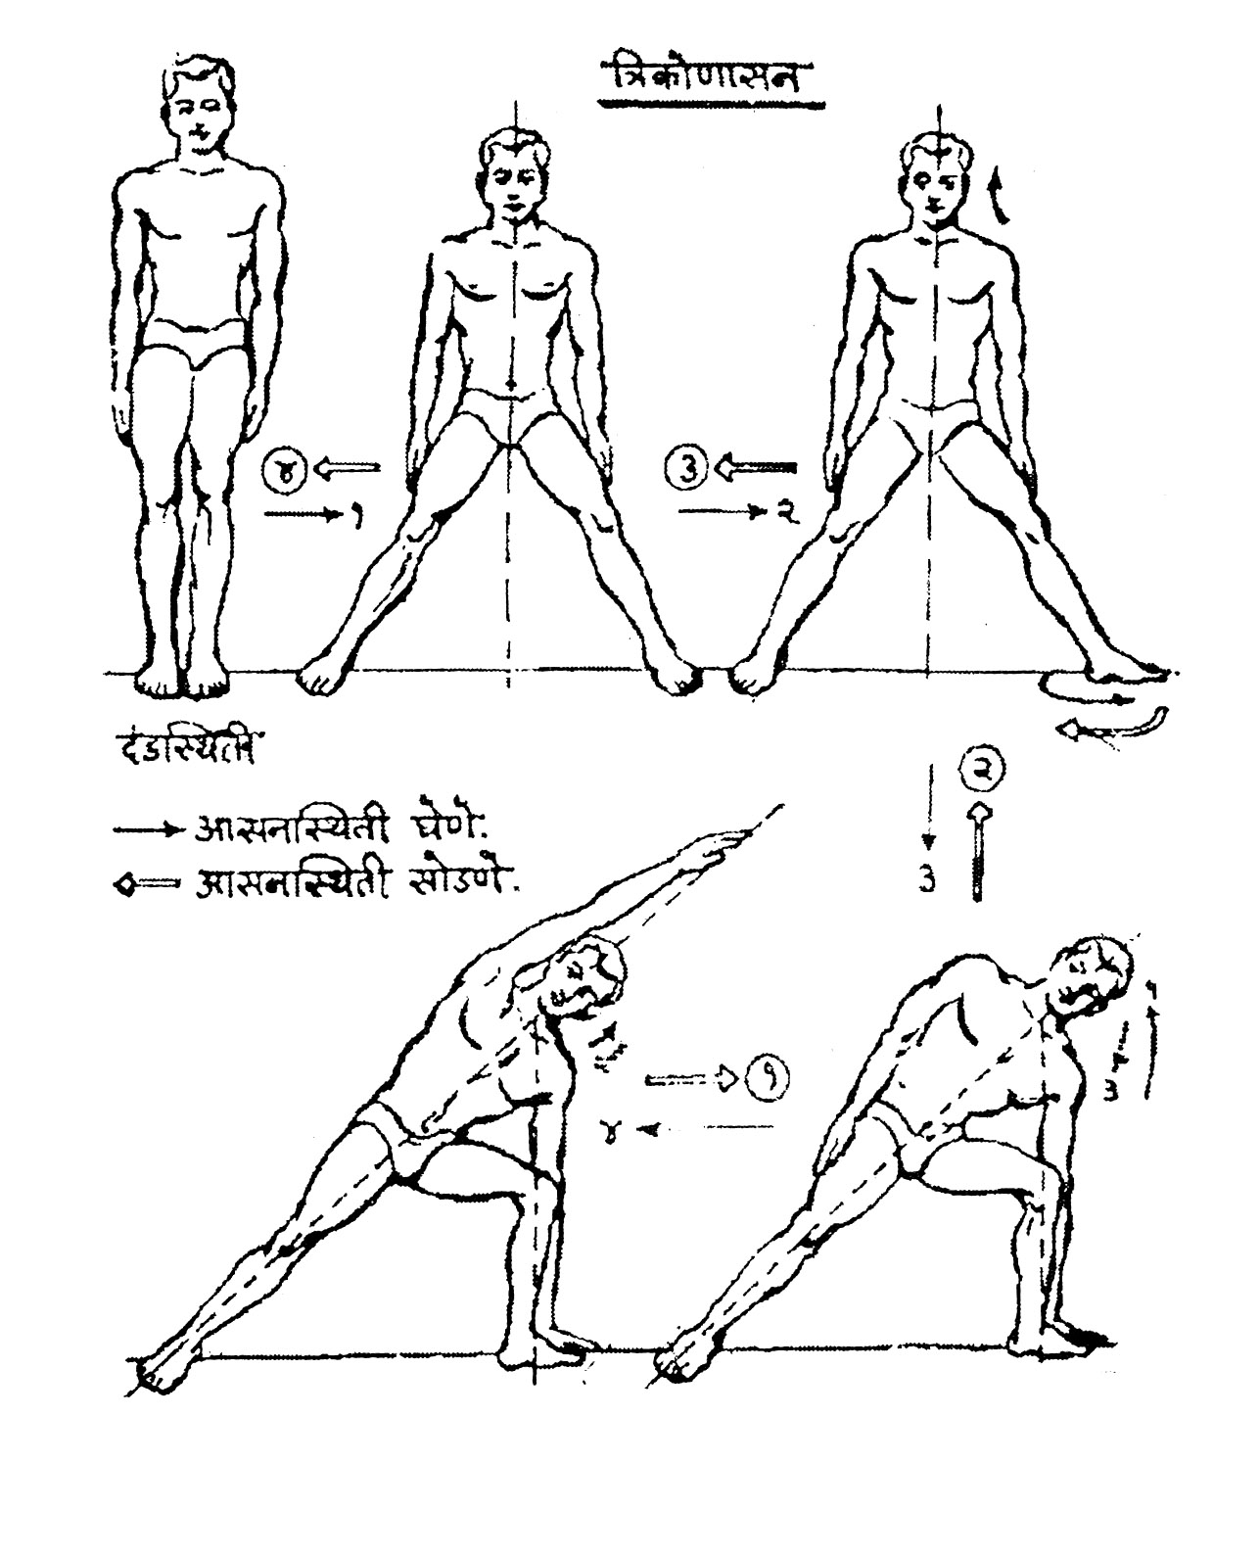

1) Coming to the right hand edge of the mat, step the left leg to the left, with the legs as wide as possible.
2) Turn the toe of the left foot out to 90 degrees and inhale.
3) Exhale, bend the left leg at the knee and come forward to place the left hand palm on the floor next to the left foot.
4) Stretch the right arm up over the head, keeping the arm straight and next to the ear. Keep the gaze fixed forward. Continue normal breathing.

The Asana Position:
It is necessary to keep the right hand, torso and right leg in one straight line in this asana. The neck and the waist should be kept straight. The arm of the right hand should be kept touching the right ear, and the gaze should be fixed forward. At this stage, the left leg is kept bent at a 90 degree angle and the left arm is kept straight, its palm placed on the floor next to the left foot. In this position the weight of the whole body rests on the left hand and the bent leg.
Releasing the Asana Position:
1) Exhale and while inhaling, bring the right hand to the side.
2) Straighten the left knee and bring the left hand to the side.
3) Turn the left toes to face the front.
4) Step the left leg to the right leg and return to standing position.
NOTE: Do the asana on the opposite side by stepping to the side with the right leg and extending the left arm up over the head.
Duration:
It should be maintained for at least one minute to have the desired stretch and benefits.
Internal Effects:
In this asana the weight of the body rests mainly on the calf of the bent leg and on the muscles of the hand resting on the floor. The whole body from the foot of the straight leg to straight hand gets stretched in one direction. This stretching has improved the functioning of the relevant muscles. This Asana is useful for the joints of the waist.
Precautions:
Any person with complaints regarding the waist and spinal column should only do this Asana under the guidance of a Yoga expert.

* * *

